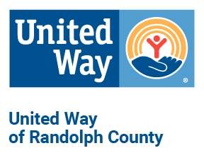
2021 Scoring Criteria for United Way of Randolph County Grant Application
Organization:
Requested Grant Amount:
Date of Grant Review:

The United Way of Randolph County has developed a tool to evaluate the quality of grant applications for funding and to support our efforts to focus on community-wide issues to improve access to education, health care, and financial barriers to help individuals to live a better quality of life.

Organizations can receive up to 100 points. The UWRC will determine funding allocations based on the point total. In order to submit a successful application, UWRC is providing organizations with the scoring criteria the allocations committee will use to review grant applications. It is strongly suggested that you answer all the questions according to the scoring criteria outlined.

Organization/Operation – 5 points
Board, staff, and volunteers – 2.5 points
Organization details – 2.5 points

Design and Execution – 45 points
Name of your program – 5 points
Funding request description – 15 points
Program summary statement – 10 points
Alignment with United Way of Randolph County Core Principles – 15 points

Measurement/Outcomes – 7.5 points
How do you define success?

Demographics – 7.5 points
How many individuals served? – 5 points
Target Population – 2.5 points

Finance Reporting – 10 points

- Audit or financial review
- IRS Form 990 or EZ 990
- Current IRS Determination Letter
- Certificate of Good Standing with Missouri Secretary of State

United Way Agency Agreement Deliverables/Partnership – 15 points

UWRC board of directors will review the UWRC Agency Agreement to ensure the deliverables of the previous year were completed. This will be measured by UWRC tracking of Section III of the Statement of Agreement.

Key points showing partnership
- Use of UW logo in newsletters, collateral, social media, etc. (Section III, A)
- Support to United Way fundraising endeavors (Section III, C).
- Submit quarterly reports on time.
- Did not solicit funds during the UWRC campaign season (Section III, D).

Other Topics – 10 points
Eligibility/Fees
Agency Collaboration

Questions from UWRC Board of Directors:

